Devops Day01 to Day20

Git and Github
- Centralized Version Control: GitHub allows developers to track every code change, experiment safely through branching, and revert to previous versions if errors occur.
Software which is track changes

- Global Collaboration: Features like Pull Requests and code reviews enable teams to propose, discuss, and merge changes seamlessly across different time zones.{Every deveolper has full
- copy of project on their laptop not just on server

Important command for Github
git log --oneline

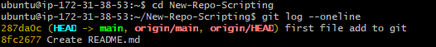

git init -Initialize new repository

git clone-clone exiting repository
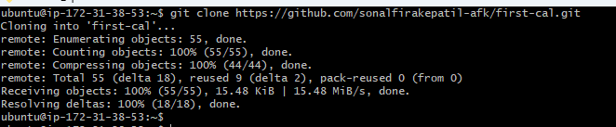

Set global username and email for git

git config --global user.name "<your username>"
git config --global user.email "<your email>"

Add file/Stage to git
git add <filename>

Add all file to git
git add .

Commit all file to git
git commit -m "<your commit message>"

Show the status of your git repository
git status

Show the branches of your git repository
git branch
Checkout to new branch
git checkout -b <branch name>

Checkout from exiting branch
git checkout

Remove branch from git
git branch -d <branch name>

Show remote origin URL
git remote -v

Add remote origin URL
git remote add origin <your remote git URL

Remove remote origin URL
git remote remove origin

Fetch all remote branches
git fetch
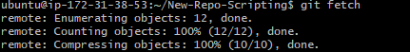

Push your local changes to remote branch
git push origin <branch name>

Pull your remote changes to local branch
git pull origin <branch name>

Check your git commit and log
git log
git log --oneline

